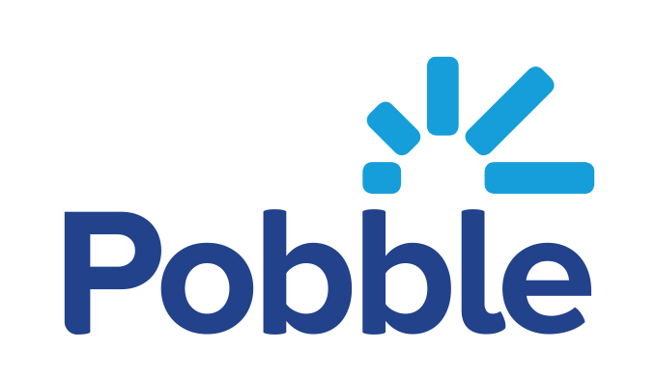

Dear Parents and Carers
We are excited to be using Pobble in our school. Pobble is an award-winning approach to teaching writing, which is part-funded by the UK Department for Education’s EdTech Innovation Fund. Pobble is shown to improve pupils’ speed, confidence and enjoyment of writing, leading to improved attainment.
One unique feature of Pobble is the sharing of children’s writing on our own online school writing celebration page (“Publishing”). As well as providing an authentic audience for your child (a key factor in raising engagement and attainment in writing), publishing will allow you to view and comment on your child’s work. It is a lovely way to share your child’s work with their peers within the Pobble community and to celebrate your child’s achievements.
Since published work may be viewed by registered Pobble users outside our school community, we would like to ask your permission for us to include your child in publishing. If you’d like your child to participate, please sign the below permission slip, photograph it, and email it to the school office admin@bearwood-pri.wokingham.sch.uk
Please note, all work is published anonymously, so no personal details of your child will be shared online. By signing up and activating your Parent Account, you can remove your linked child’s published work from the public view at any time. Please read Pobble’s terms and conditions (https://my.pobble.com/legalintroduction) for more information.
If you have any questions, please do not hesitate to contact your class teacher. We are excited to be using Pobble in our school and look forward to your support and participation.
Yours sincerely
Ms Funmi Alder
Head teacher
 Please return to the school office
I want my child to participate in publishing on Pobble.
Child first name: Child surname: Class:
Parent / carer name: Signed:

