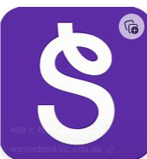 Seesaw communication platform

In our Foundation Stage we use a platform called Seesaw to communicate with parents. We will upload photos and videos of what the children are doing in school and send reminder messages such as ‘non uniform day’ or ‘library books in tomorrow please’. We have trialled using it this year and parents have been happy with how it has worked.
Seesaw is an app for parents to stay in touch with what your child is doing throughout the school day. Posts are not every day, but we try to get one up a week or when there is a special activity. It is an app that you download on your phone and connect directly to your child only.
Children are uploaded onto the system by first name only and then can be connected a family member account from home (your personal email address). The app then notifies you of a new post or message from the teacher so you can read it when it is convenient for you.
When you view a post from home you will be able to see other children in the photos, and other family members will be able to see yours. An example post is shown below from our current Reception children.
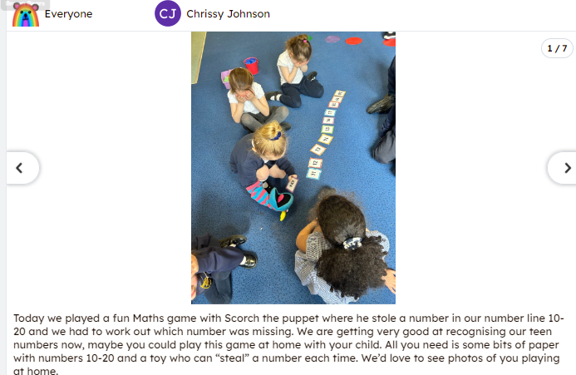

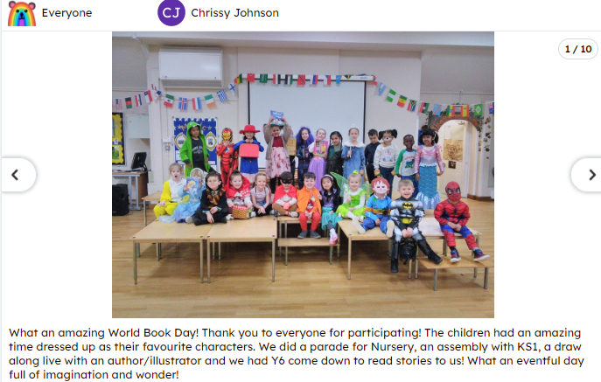

You will get specific information on how to download the app and connect to your child’s account on the parent information evening. In order to include your child’s photos in these posts we ask that you sign below to give your consent. These photos are not shared on any public platform and can only be seen by current Bearwood Reception class parents by using a secure log in.

- I give consent for my child to be added to Seesaw and for their photo to be shared on the platform ___________________________ (parent/carer)

