Appendix D2

CARE PLAN FOR EMERGENCY TREATMENT OF SEIZURES
IN CHILDREN AND YOUNG PEOPLE
(With no prescribed emergency medication)

This document is distributed through identified Health Care Professionals in Berkshire Healthcare Foundation Trust and Royal Berkshire NHS Foundation Trust

and should be accompanied by the appropriate training.

PERSONAL DETAILS

Allergies:

Name:

NHS Number:

School/Establishment:

Date of Birth:

Address:

Parents/Guardians Name:

1st Emergency Contact: | Name:  Relationship to child/young person:  Contact Number:
2nd Emergency Contact Number:  : | Name:  Relationship to child/young person:  Contact Number

This care plan was written by: (Name of Health Professional)
Contact details:

Date:

Review Date (if no changes prior to review date):

To be completed agreed and signed by the parent/carer and young person. Record all details of seizures e.g. goes stiff, falls, convulses down both sides of body.

Seizure Description:

Duration:

Pattern:

Triggers:

Frequency:

Recovery:
(e.g. length of time)

Additional Specific Care needs during seizure activity
i.e. Use of oxygen, stopping feeds etc.

Additional Specific Care needs after seizure activity
i.e. Use of oxygen, sleep, pain relief, food/drink

Seizure Management Plan

- Stay calm.
- Look around - is in a dangerous place? If not, do not move them. Move objects like furniture away from them.
- Note the time the seizure starts.
- Stay with them. If they do not collapse but seem blank or confused, gently guide them away from any danger. Speak quietly and calmly.
- Cushion their head with something soft if they have collapsed to the ground.
- Do not hold them down.
- Do not put anything in their mouth.
- Check the time again. If the seizure does not stop after 5 minutes, call for an ambulance. .
- After the seizure has stopped, put them into the recovery position, or follow specific care needs below, and check that their breathing is returning to normal. Gently check their mouth to see that nothing is blocking their airway such as food or false teeth. If their breathing sounds difficult after the seizure has stopped, call for an ambulance
- Stay with them until they are fully recovered.

Call 999: When a seizure has lasted longer than: ……….. minutes or if concerned about the child/young person at any time.

Call 999 if you are ever concerned about the child/young person or they have injured themselves

AGREEMENT FOR THE MANAGEMENT OF SEIZURES

I/we the undersigned give our consent and approval, as appropriate, for paid/volunteer employees who are acting in “loco parentis” to support our child as instructed and trained for, in an emergency.

I am/we are aware that further advice and information can be sought from the Consultant/Epilepsy Nurse Specialist or Epilepsy Action (www.epilepsy.org.uk).

This care plan is to ensure that the individual child receives the correct emergency treatment for epilepsy. It is the responsibility of the parent/carer to ensure that the

Health Care Professional is informed of any changes to their child’s emergency treatment so that the care plan can be changed accordingly.

PARENT/CARER

Name: (Print)
Relationship to child:
Signed: Date:
Name: (Print)
Relationship to child:
Signed: Date:

YOUNG PERSON (where appropriate)

Name: (Print)
Signed: Date:

HEAD OF ESTABLISHMENT/SETTING/CHILDMINDER: (Optional)

Name (Print)
Signed: Date:

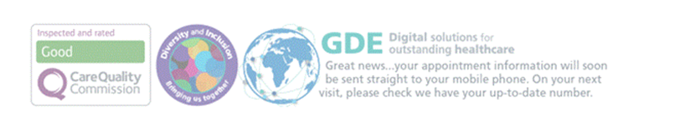

EMERGENCY TREATMENT OF SEIZURES IN CHILDREN AND YOUNG PEOPLE (WITH NO EMERGENCY MEDICATION)

TRAINING RECORD

Date: …………….

Trained Volunteer employed at:

Volunteers trained in the management of seizures – at least one person to be available at ALL times.

NAME | SIGNATURE | NAME | SIGNATURE

Any other relevant information?

..

I certify that the above have completed the relevant training.

Signature: Date: .

Name: (Print) Telephone: .
Designation………………………………………………………………………………..
Address: ……………………………………..

One copy to be retained by Community Nursing Team, one copy to be kept with child at community setting and/or appropriate department.

Care Plan Distribution List

Distributed To | Date | Comments

