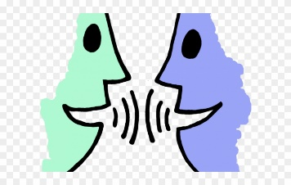
Talk Tasks

Learning to communicate well is vital. Children with good communication skills are more likely to be confident and do well at school. Developing speaking & listening skills is also part of the National Curriculum.

Have a break from the laptop or tablet screen and try some of these ideas!

Instructions
    - Give instructions to your mum / dad / brother / sister to walk from one part of the house or garden to another. Could they follow your instructions? ADid you use good vocabulary like left, right, forward, turn, backwards, stop…?
    - Sit back-to-back with someone at home. Draw a simple picture or shape on a piece of paper. Give instructions to see if your drawing partner can draw the same as you just by listening to your instructions.
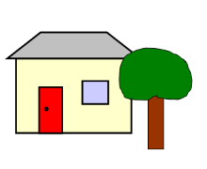
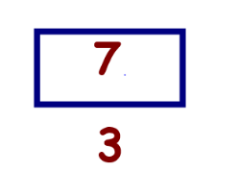

Role Play

- Act out parts of a story
- Role-play shopping, making breakfast, eating in a cafe

Talk about a story

    - Listen to a story on Book at Bedtime. E.g. https://www.bbc.co.uk/iplayer/episode/m000c01c/cbeebies-bedtime-stories-730-robbie-williams-jazz-dog and talk about

      - the tone of voice: is it soothing, whispering, tense…Why?
      - pace: is it read quickly, slowly… why is it read quickly or slowly?
      - Volume: how loudly or quietly is the story read and why.

- Record yourself reading a story. How can you make it sound more interesting? Can you change the way you read it to make the story sound exciting or funny?

Picture Questions
- Look at a picture. It could be a picture in a story book or a factual book or a picture you have found of something interesting.
- An adult or older brother / sister can ask you a question about the picture and you must try to answer in a full sentence.
- The child can then try to ask a question for the adult to answer (this can be difficult for younger children)

Example:
How many people are in the picture? There are two people in the picture.
What is Goldilocks doing? Goldilocks is sleeping in Baby Bear’s bed.
Who is making a star? Laura is making a star.
Where is the aeroplane? It is in the sky.

Please note – start with easier questions like ‘How many…?’ ‘Who?’ and ‘What?’ ‘Where?’ and ‘Why’ questions are much harder, especially for very young children.

Talk about what you have been learning.
Use these sentence starters to start a conversation about learning:

    - Teach me about…
    - Can you tell me more about…?
    - Why do you think…?
    - Do you agree or disagree…?

Interview a friend or relative remotely
- Ask a friend or relative if they would be prepared to be interviewed on Skype / FaceTime / over the phone
- Think of some questions to ask them – write them down so you don’t forget
- Interview – ask your questions and listen carefully to the answers
- Think about what you have learnt about your friend or relative

Fun talk games
- Would you rather…
  - have hands for feet or feet for hands?
  - be Doctor Who or Superman/woman?
  - be told you could never again eat sweets or crisps?

Why?
- Odd one out
  - Take turns to think of three or four items. Discuss which could be the odd one out and why.
E.g.
Apple, banana and orange.
  - Banana could be the odd one out because it is a different shape
  - Apple could be the odd one out because you can eat its skin
  - Orange could be the odd one out because it is the only one that has segments

bus, car, taxi
  - Car could be the odd one out because you have to pay to use the others
  - Bus could be the odd one out because it can carry more people than a car or taxi

